Test Case: tc001_SPX_Dev5_Crear_Solicitud_Articulo_Almacen
Step 1 - Enter username and password and click to button Enter : Credentials Entered
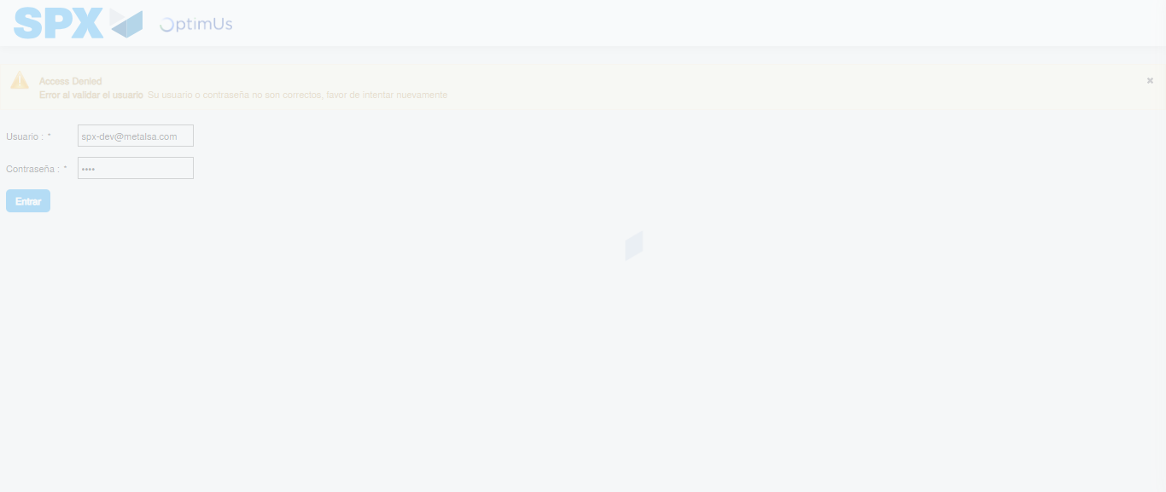Image file-name: QC_Testing-tc001_SPX_Dev5_Crear_Solicitud_Articulo_Almacen-1787930207448

Step 2 - Select to UEN and Access to Request for a New Inventory Item : UEN Correctly selected and Correct access
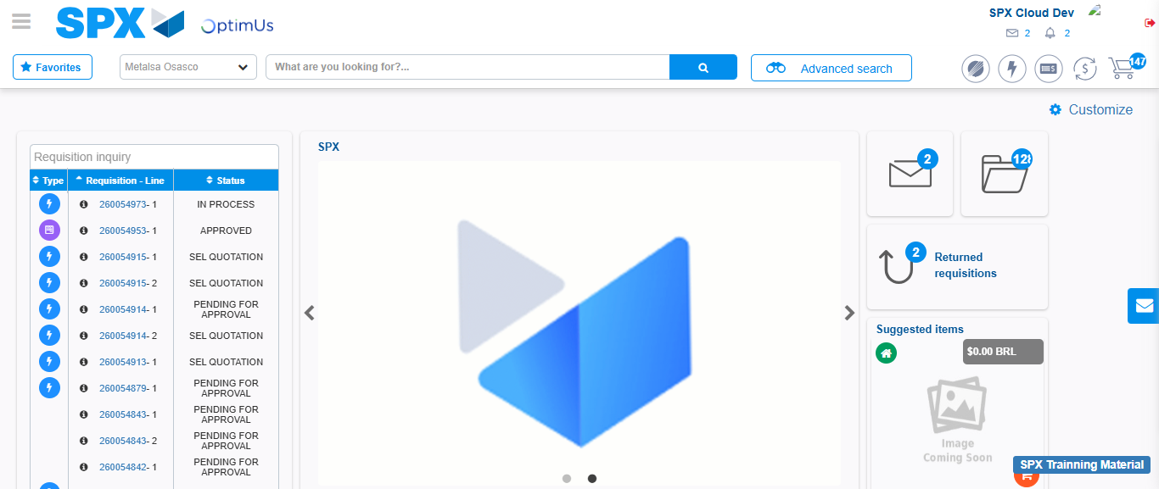Image file-name: QC_Testing-tc001_SPX_Dev5_Crear_Solicitud_Articulo_Almacen-1787930233416

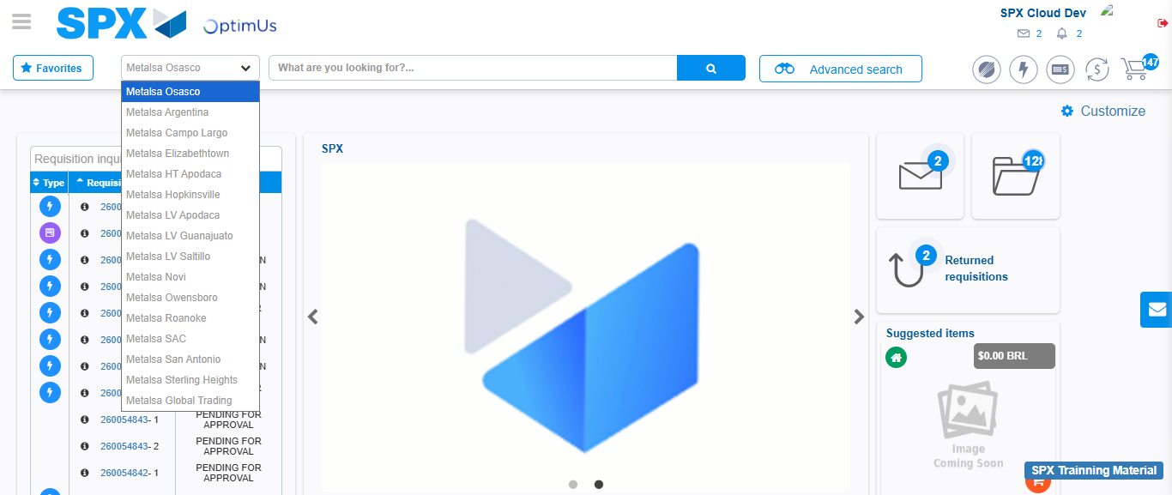Image file-name: QC_Testing-tc001_SPX_Dev5_Crear_Solicitud_Articulo_Almacen-1787930233889

Image file-name: QC_Testing-tc001_SPX_Dev5_Crear_Solicitud_Articulo_Almacen-1787930239718

Step 3 - Select options first section : Options seleted correctly
Image file-name: QC_Testing-tc001_SPX_Dev5_Crear_Solicitud_Articulo_Almacen-1787930239937

Image file-name: QC_Testing-tc001_SPX_Dev5_Crear_Solicitud_Articulo_Almacen-1787930240110

Step 4 - Select options at Screen: Options seleted correctly
Image file-name: QC_Testing-tc001_SPX_Dev5_Crear_Solicitud_Articulo_Almacen-1787930239937

Image file-name: QC_Testing-tc001_SPX_Dev5_Crear_Solicitud_Articulo_Almacen-1787930240110

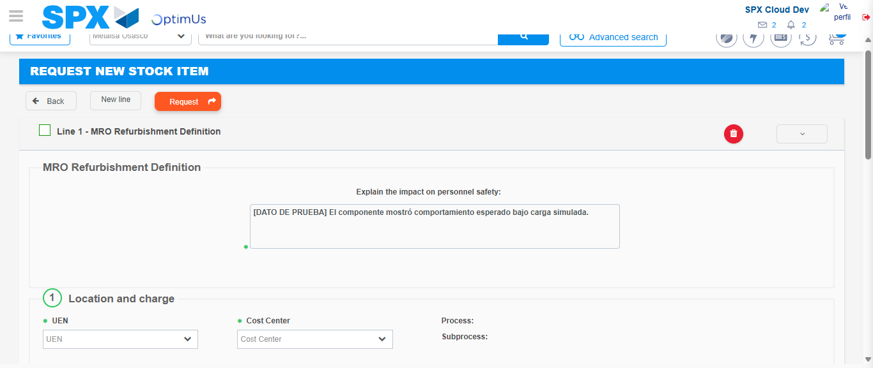Image file-name: QC_Testing-tc001_SPX_Dev5_Crear_Solicitud_Articulo_Almacen-1787930246045

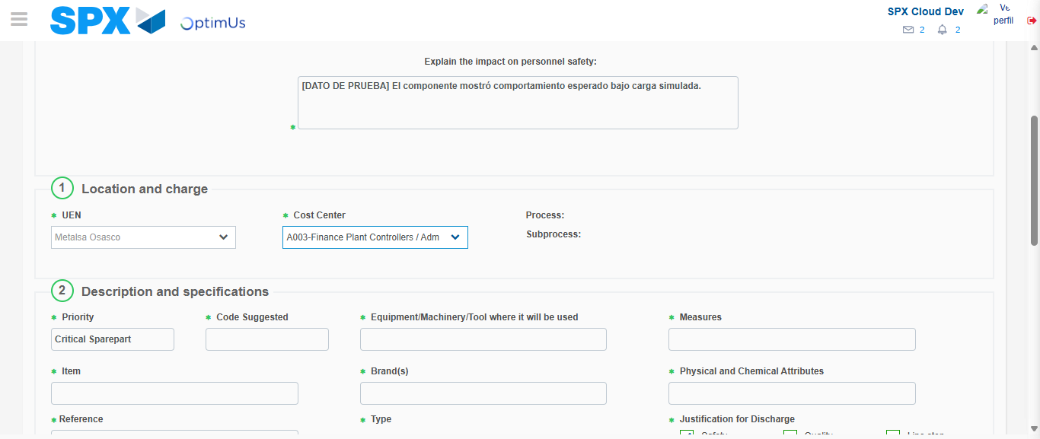Image file-name: QC_Testing-tc001_SPX_Dev5_Crear_Solicitud_Articulo_Almacen-1787930248322

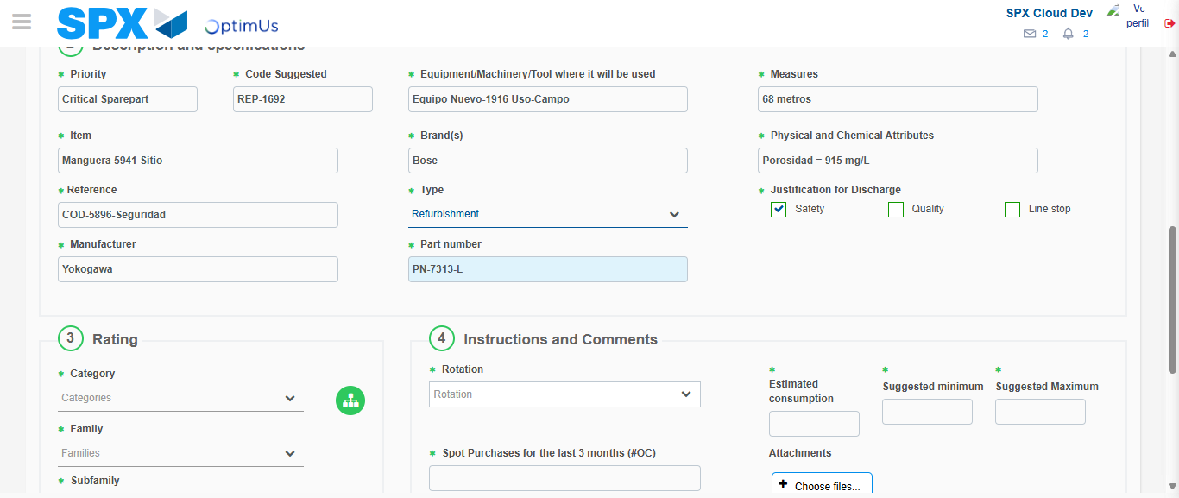Image file-name: QC_Testing-tc001_SPX_Dev5_Crear_Solicitud_Articulo_Almacen-1787930249460

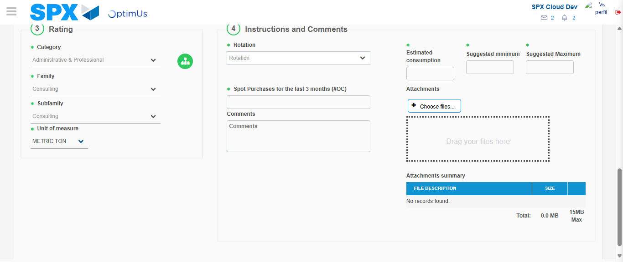Image file-name: QC_Testing-tc001_SPX_Dev5_Crear_Solicitud_Articulo_Almacen-1787930253621

Step 5 - Request New Item : Request Accepted
Image file-name: QC_Testing-tc001_SPX_Dev5_Crear_Solicitud_Articulo_Almacen-1787930233416

Image file-name: QC_Testing-tc001_SPX_Dev5_Crear_Solicitud_Articulo_Almacen-1787930233889

Image file-name: QC_Testing-tc001_SPX_Dev5_Crear_Solicitud_Articulo_Almacen-1787930239718

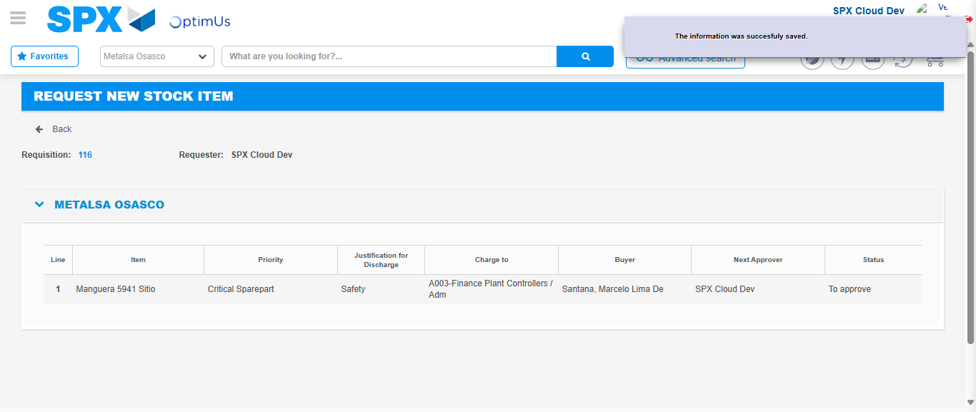Image file-name: QC_Testing-tc001_SPX_Dev5_Crear_Solicitud_Articulo_Almacen-1787930260182

Image file-name: QC_Testing-tc001_SPX_Dev5_Crear_Solicitud_Articulo_Almacen-1787930260318

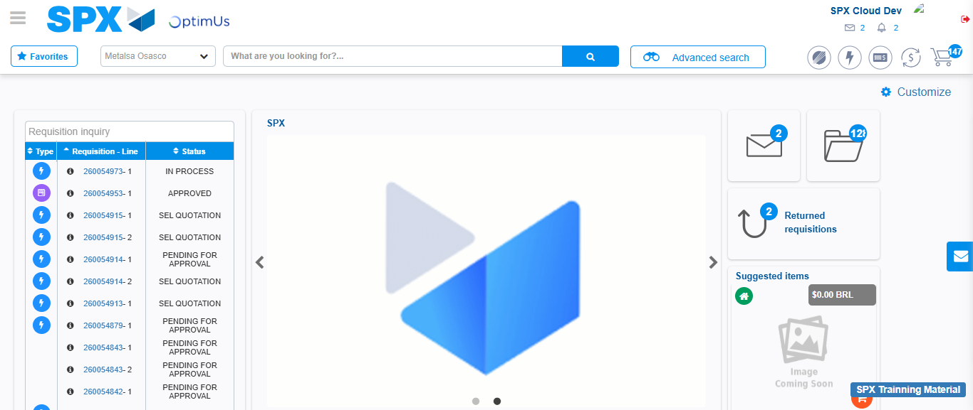Image file-name: QC_Testing-tc001_SPX_Dev5_Crear_Solicitud_Articulo_Almacen-1787930281575

Step 7 - Return to Main Page SPX : Return to Main Page SPX
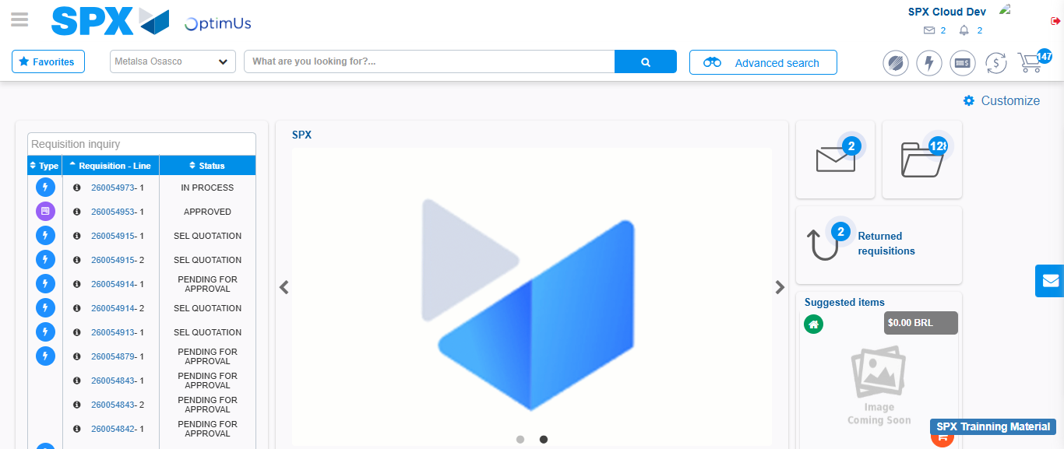Image file-name: QC_Testing-tc001_SPX_Dev5_Crear_Solicitud_Articulo_Almacen-1787930281942

